PROJECT REPORT
ON

Analysis of OLA Cab’s On-Demand Ride-Hailing Service: A Comparative Study of

Different SDLC Models

"A Comparative Study of Different Models in Relation to OLA Cab’s Ride-Hailing and Mobility Services"
Submitted to
NMAM INSTITUTE OF TECHNOLOGY, NITTE
(Off-Campus Centre, Nitte Deemed to be University, Nitte - 574 110, Karnataka, India)
In partial fulfilment of the requirements for the award of the
Degree of Bachelor of Technology
In
INFORMATION SCIENCE AND ENGINEERING
By
Under the guidance of
Dr. Jason Elroy Martis, Associate Professor,
Department of Information Science and Technology,
NMAM Institute of Technology. Nitte Karnataka, India

Comparative Analysis of SDLC Models and Requirements Engineering for OLA Cab System

1. Introduction

1.1 Background
OLA Cabs is one of India’s leading ride-hailing platforms, connecting millions of passengers with drivers through a mobile application. Founded in 2010, OLA transformed urban transportation by introducing technology-driven cab booking, real-time tracking, digital payments, and data-based pricing mechanisms such as surge pricing.

Unlike traditional taxi services, OLA operates in a highly dynamic environment. Customer expectations evolve rapidly, regulations change frequently, and competition in the ride-hailing sector is intense. Features like emergency assistance, real-time ride tracking, digital wallets, loyalty programs, and electric vehicle integration must continuously adapt to user demands.

In addition, this report explores requirements engineering practices, including requirement elicitation, specification, validation, and management strategies tailored for OLA.

1.2 Objectives

• To evaluate the suitability of Waterfall, Spiral, and Incremental SDLC models for OLA.

To prepare a simplified but structured requirements document.

To design a practical requirements

validation strategy.

• To recommend the most appropriate development approach for OLA.
2. Comparative Analysis of SDLC Models

2.1 Waterfall Model
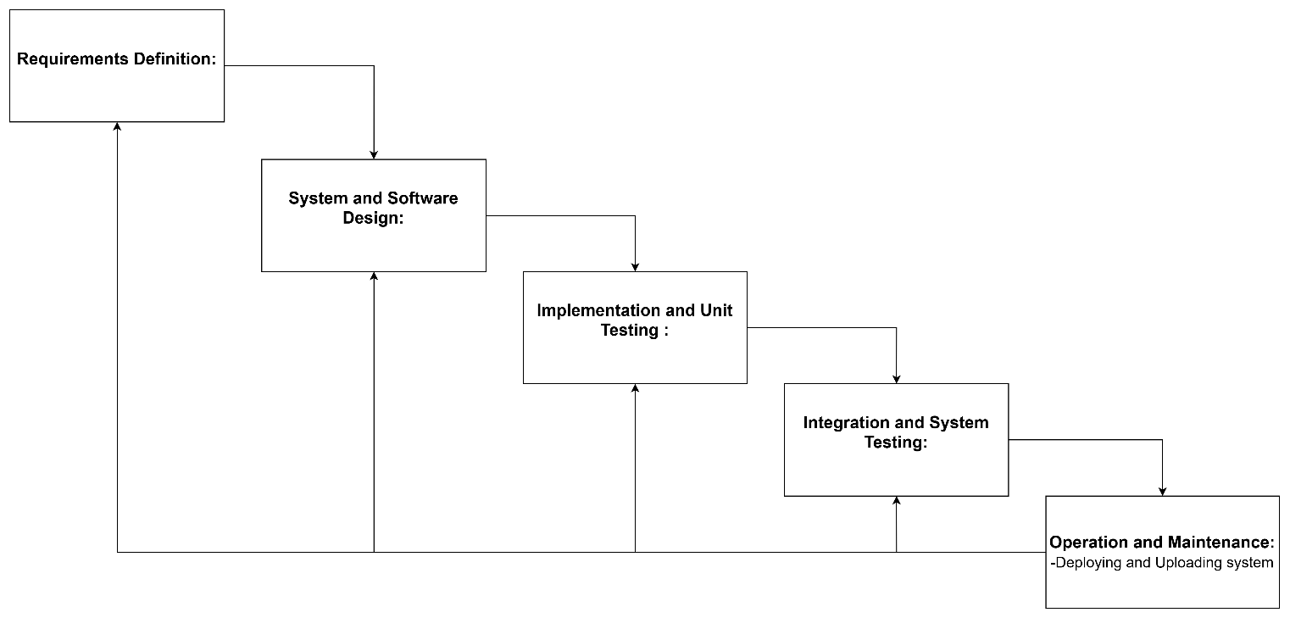

2.1.1 Overview
The Waterfall model is a linear and sequential development approach. Each phase - Requirements → Design → Implementation→ Testing → Deployment → Maintenance - must be completed before moving to the next.

It works best when requirements are stable, clearly defined, and unlikely to change. Documentation is extensive, and project milestones are predictable.

2.1.2 Suitability for OLA
*Functional Requirements:*

Not suitable. OLA frequently introduces new features such as ride-sharing, safety alerts, and new payment options. Waterfall's rigid structure makes adaptation difficult.

*Non-Functional Requirements:

Scalability and security improvements may require redesign. Late-stage

changes are costly.

*Risk & Change Management: Low adaptability. Regulatory changes like data privacy laws cannot be easily incorporated once development

progresses.

*Time & Cost Constraints:

Initial planning costs are lower, and timelines appear predictable. However, rework due to requirement changes becomes expensive.

2.1.3 Example
If OLA decides to integrate a new UPI payment gateway after testing is completed, the Waterfall approach would require revisiting design and implementation stages, increasing cost and delay.
2.2 Spiral Model

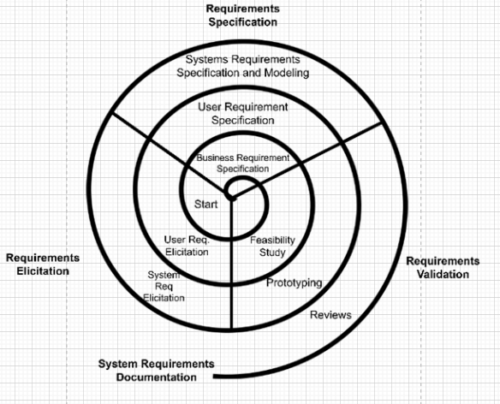

2.2.1 Overview
The Spiral Model is an iterative Software Development Life Cycle (SDLC) methodology that merges the phases of the Waterfall Model with a focus on risk assessment. This model is particularly advantageous for extensive and intricate projects that involve considerable risks.
2.2.2 Suitability for OLA

- Functional Requirements: Highly adaptable. The iterative nature of risk analysis enables the prioritization of essential features (e.g., emergency response tools) at an early stage.
- Non-Functional Requirements: Excellent. Risk-driven iterations effectively address scalability during peak demands and strengthen security measures (e.g., data encryption).
- Risk/Change Management: Robust. Regular risk evaluations help in mitigating potential issues such as driver fraud or system outages.

2.2.3 Example
A prototype for real-time tracking could serve to validate performance requirements prior to full-scale development.
2.3 Incremental Development
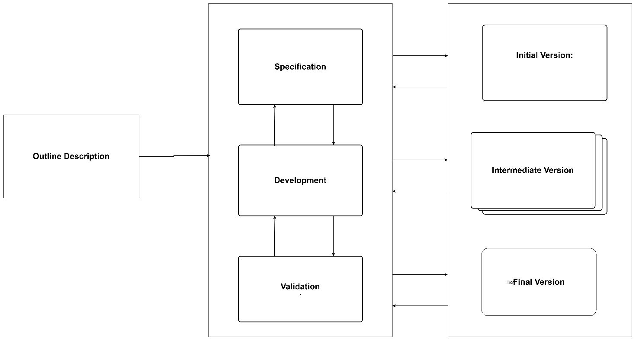

2.3.1 Overview
The Incremental Model divides the system into smaller modules (increments). Each increment adds new functionality to the existing system.

Core features are delivered first, followed by advanced features in later releases.

2.3.2 Suitability for OLA

- *Functional Requirements:
- Highly suitable. Basic ride booking can be developed first, followed by ride-sharing, loyalty programs, and subscription plans.

- *Non-Functional Requirements:

- *Risk & Change Management:
- Flexible. Changes affect only the current increment rather than the whole system.

2.3.3 Example
Version 1: Basic booking + payments
Version 3: Premium rides + loyalty point
3. Requirements Document

3.1 Functional Requirements
Requirements Document (Simplified)

3.1 Functional Requirements

3.1.1 User Registration

* Social login (Google, Facebook)
* Secure password storage

3.1.2 Ride Booking

* Real-time availability display
* Fare estimation
* Multiple payment methods (UPI, Cards, Wallet)

3.1.3 Driver Assignment

* Location-based matching

* Real-time tracking

3.1.4 Customer Support

* In-app chat
* 24/7 emergency helpline

3.2 Non-Functional Requirements

3.2.1 Scalability

* Support 100,000+ concurrent users
* Horizontal cloud scaling

### 3.2.2 Security

### 3.2.3 Availability

* 99.9% uptime
* Failover mechanisms

### 3.2.4 Performance

* Response time < 2 seconds
* Optimized database queries
4. Requirements Validation Strategy

4.1 Strategy
. Requirements Validation Strategy

## 4.1 Prototyping

## 4.2 Reviews

Sprint reviews with stakeholders using Jira or Trello.

## 4.3 Testing

## 4.4 Feedback Loops

* In-app ratings
* User surveys
* Regular stakeholder meetings
4.2 Challenges
5. Challenges

### 5.1 Scope Creep

Continuous feature addition may delay project completion.

### 5.2 Non-Functional Validation

5. Conclusion
For OLA Cab, the Incremental Development Model is most suitable because:

* It supports evolving requirements.
* It delivers core features quickly.
* It allows continuous user feedback.

The Spiral Model should be used for high-risk components such as payment systems and data security.

6. References

- Sommerville, I. (2016). Software Engineering (10th ed.). Pearson.
- Royce, W. W. (1970). Managing the Development of Large Software Systems. In Proceedings of IEEE WESCON.
- Boehm, B. W. (1988). A Spiral Model of Software Development and Enhancement. IEEE Software, 5(2), 61–72.
- Ambler, S. W. (2004). The Object Primer: Agile Model-Driven Development with UML 2.0 (3rd ed.). Cambridge University Press.
- Krutchen, P. (1995). The 4+1 View Model of Architecture. IEEE Software, 12(6), 42–50.

7. Appendices

7.1 Appendix A: Comprehensive Comparison Table

Criteria | Waterfall Model | Spiral Model | Incremental Development
Functional Requirements | Poor fit for evolving requirements | High adaptability | Ideal for incremental feature addition
Non-Functional Requirements | Limited flexibility | Excellent for addressing scalability and security | Moderate, can be addressed incrementally
Risk Management | Low tolerance for changes | Strong risk assessment and mitigation | Flexible, reduces impact of changes
Time/Cost Constraints | Predictable timelines, high rework costs | Higher upfront costs, long-term savings | Faster delivery, manageable long-term costs

7.2 Appendix B: Additional References

- IEEE Software Engineering Standards
- OMG Model-Driven Architecture
- Agile Modeling

8. In-Depth Analysis of Each Model

8.1 In-Depth Analysis of the Waterfall Model

8.1.1 Advantages

- Predictability: The Waterfall Model presents a transparent and predictable project timeline.
- Documentation: Comprehensive documentation is produced, beneficial for future reference and upkeep.
- Simplicity: The model is clear-cut and easy to comprehend.

8.1.2 Disadvantages

- Rigidity: Once a phase concludes, modifying it becomes challenging.
- Risk of Late Modifications: Changing requirements late in the project can incur substantial costs.
- Lack of Early User Feedback: Users do not review the system until project completion, potentially resulting in dissatisfaction.

8.1.3 Case Study: OLA Cab

- Scenario: OLA aims to introduce a new feature for real-time ride tracking.
- Waterfall Approach: A complete redesign and retesting of the entire system would be necessary, resulting in considerable delays and expenses.
- Outcome: The Waterfall Model proves unsuitable for this scenario due to its lack of flexibility.

8.2 In-Depth Analysis of the Spiral Model

8.2.1 Advantages

- Risk Management: The Spiral Model facilitates early detection and mitigation of risks.
- Flexibility: The model can adapt to shifting requirements.
- User Engagement: Users can contribute feedback early in the process, resulting in an improved final product.

8.2.2 Disadvantages

- Complexity: The model is more intricate than the Waterfall Model, necessitating more experienced project managers.
- Costs: The iterative nature may lead to increased expenditures.
- Time Consumption: The process may take longer due to multiple cycles.

8.2.3 Case Study: OLA Cab

- Scenario: OLA requires the implementation of a new payment gateway.
- Spiral Approach: A prototype is developed and assessed with user input. Feedback is integrated, and the feature is refined prior to full deployment.
- Outcome: The Spiral Model is appropriate for this scenario, enabling early risk evaluation and user feedback.

8.3 In-Depth Analysis of Incremental Development

8.3.1 Advantages

- Flexibility: The model is remarkably adaptable to evolving requirements.
- User Feedback: Users can provide insights on each increment, enhancing the final output.
- Quicker Delivery: Core functionalities can be launched rapidly, with additional features introduced progressively.

8.3.2 Disadvantages

- Complexity: Managing the model can become complicated, particularly with numerous increments.
- Integration Challenges: Incorporating new increments can pose difficulties and potentially introduce bugs.
- Scope Creep: There is a danger of scope creep if not properly overseen.

8.3.3 Case Study: OLA Cab

- Scenario: OLA intends to implement a new ride-sharing feature.
- Incremental Approach: The fundamental ride-booking feature is developed initially. Later increments will introduce ride-sharing functionality.
- Outcome: The Incremental Development model fits this scenario well, allowing for iterative advancement and user input.

9. Comprehensive Requirements Engineering Process

9.1 Requirements Elicitation

9.1.1 Techniques

- Interviews: Engage stakeholders through interviews to collect requirements.
- Surveys: Deploy surveys to gather feedback from a wider audience.
- Observation: Observe users in their operational environment to gain insights into their needs.

9.1.2 Tools

- Jira: Utilized for requirement tracking and feedback management.
- Trello: Employed for overseeing the requirements backlog.
- Figma: Applied for the development of wireframes and prototypes.

9.2 Requirements Specification

9.2.1 User Requirements

- High-Level Requirements: Articulate the general goals and objectives of the system.
- Detailed Requirements: Decompose high-level requirements into specific, actionable tasks.

9.2.2 System Requirements

- Functional Requirements: Specify the precise functions the system must execute.
- Non-Functional Requirements: Outline the system's performance, security, and other non-functional characteristics.

9.3 Requirements Validation

9.3.1 Techniques

- Prototyping: Construct prototypes to verify requirements with users.
- Reviews: Facilitate reviews with stakeholders to validate compliance with requirements.
- Testing: Execute functional and non-functional testing to confirm requirements.

9.3.2 Tools
- Automated Testing Tools: For validating functional and non-functional aspects.
- Feedback Tools: For obtaining user feedback on prototypes.

9.4 Requirements Management

9.4.1 Techniques

- Change Control: Establish a change control process to oversee requirement modifications.
- Version Control: Implement version control systems to document changes in requirements.
- Documentation: Preserve exhaustive documentation of requirements and modifications.

9.4.2 Tools

- Version Control Systems: Such as Git for monitoring changes.
- Documentation Tools: Such as Confluence for upholding requirements documentation.

10. Case Studies and Real-World Examples

10.1 Case Study: OLA Cab

10.1.1 Scenario: Real-Time Ride Tracking

- Objective: Implement real-time ride tracking for passengers.
- Approach: Employ the Incremental Development model to develop the feature in phases.
- Outcome: Core ride-booking functionality is delivered initially, followed by real-time tracking in a subsequent increment.

10.1.2 Scenario: New Payment Gateway

- Objective: Integrate a new payment gateway.
- Approach: Utilize the Spiral Model to create a prototype, gather feedback, and enhance the feature.
- Outcome: The new payment gateway is successfully integrated with minimized risk.

10.2 Case Study: Uber

10.2.1 Scenario: Surge Pricing

- Objective: Introduce surge pricing to manage demand.
- Approach: Apply the Incremental Development model to implement surge pricing incrementally.
- Outcome: Surge pricing is effectively implemented and refined based on user feedback.

10.2.2 Scenario: Driver Background Checks

- Objective: Implement driver background checks to guarantee safety.
- Approach: Utilize the Spiral Model to develop a prototype, gather feedback, and enhance the feature.
- Outcome: Driver background checks are successfully executed with minimal risk.

11. Conclusion and Recommendations
6. Conclusion

For OLA Cab, the Incremental Development Model is most suitable because:

* It supports evolving requirements.
* It delivers core features quickly.
* It allows continuous user feedback.

The Spiral Model should be used for high-risk components such as payment systems and data security.

The Waterfall Model may be applied only for stable modules like static content or internal reporting tools.

A hybrid approach combining Incremental and Spiral methodologies will provide both agility and strong risk management
11.2 Recommendations
12. Future Work

- Continuous Improvement: Regularly assess and refine the development process based on feedback and emerging requirements.
- Adapt to Emerging Technologies: Remain aware of new technologies and integrate them into the development framework.
- Enhance User Experience: Consistently improve the user interface and experience informed by user feedback.

